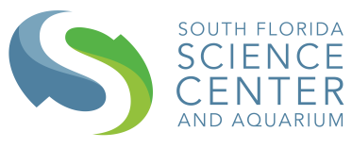
South Florida Science Center and Aquarium

Summer Camp Scholarship Application

We are offering a Summer Camp Scholarship for girls in Title 1 Schools in Palm Beach County. Join us for our upcoming Summer STEM Adventures for young scientists and engineers ages 4-14! Campers will experience mind-blowing experiments, program robots, explore virtual reality, and much more during this epic STEM Adventure! Campers can pick one from any of our 10 weeks of science or tech camps. Students must attend all 5 days of camp. For a chance to attend this camp free of cost, please fill out the following application and submit to Zary Roque, our Assistant GPC at zroque@sfsca.org by April 30th, 2019. Winners of the scholarship will be notified by May 3rd, 2019.

Name of Child_______________________________________
School (must be Title 1) _______________________________
Date of Birth_________________________________________
Name of Parent______________________________________
Address_____________________________________________
Telephone number____________________________________
Parent E-mail address_________________________________

4801 Dreher Trail North | West Palm Beach, FL 33405 | (561) 832-1988 | sfsciencecenter.org

