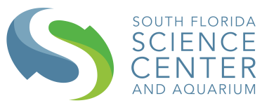
South Florida Science Center and Aquarium

Spring Camp Scholarship Application

We are offering a Spring Camp Scholarship for Title 1students in Palm Beach County. Join us for our upcoming Spring STEM Adventures for young scientists and engineers ages 4-12! Campers will experience mind-blowing experiments, program drones, and much more during this epic STEM Adventure! Campers can pick from our science or tech camp. Before/after care will be included. Students must attend all 5 days of camp. For a chance to attend this camp free of cost, please fill out the following application and submit to Zary Roque at zroque@sfsca.org by February 27th. Winners of the scholarship will be notified by March 2nd, 2020.

Name of Child_______________________________________
School (must be Title 1) _______________________________
Date of Birth_________________________________________
Name of Parent______________________________________
Address_____________________________________________
Telephone number____________________________________
Parent E-mail address_________________________________

4801 Dreher Trail North | West Palm Beach, FL 33405 | (561) 832-1988 | sfsciencecenter.org

